**College code : 6208**

**Name. :SHALINI R S**

**IBM Reg No : au620821106084**

**Project name: Earthquake prediction model using python**

**PHASE-1**

**Definition:**

It is not currently possible to predict exactly when and where an earthquake will occur, nor how large it will be. However, seismologists can estimate where earthquakes may be likely to strike by calculating probabilities and forecasts.

**Designing**

**Data Exploration and Understanding:**

Begin by loading and exploring the dataset to understand its structure and the features it contains. Identify key features that might be relevant for earthquake prediction, such as location, depth, time, etc. Perform basic statistical analysis and visualization to gain insights into the data.

**Data Preprocessing:**

Handle missing values and outliers appropriately. Convert categorical data into numerical format if necessary. Normalize or scale numerical features to ensure they have a similar range.

**Data Visualization:**

Create visualizations to better understand the distribution of earthquake magnitudes, their frequency over time, and their geographic distribution on a world map. These visualizations can help identify patterns and correlations in the data.

**Data Splitting:**

Split the dataset into training and testing sets. Typically, an 80-20 or 70-30 split is used. Ensure that the data is shuffled randomly before splitting to avoid any bias.

**Feature Engineering:**

Consider feature engineering techniques to create new features or transformations that might improve model performance. For example, you can calculate distances between earthquake locations and known fault lines.

**Model Selection:**

Choose an appropriate machine learning model for regression, as you're predicting earthquake magnitudes. Given the complexity of the task, you might want to start with a neural network model like a feedforward neural network or a more advanced architecture like a recurrent neural network (RNN) if time series information is important.

**Model Training:**

Train your selected model using the training data. Tune hyperparameters to optimize model performance. Consider using techniques like cross-validation for hyperparameter tuning.

**Model Evaluation:**

Evaluate the model using the testing dataset. Use appropriate evaluation metrics for regression tasks, such as Mean Absolute Error (MAE) or Root Mean Square Error (RMSE).

**Visualization of Results:**

Visualize the model's predictions against the actual earthquake magnitudes to assess its performance.

**Iterate and Improve:**

If the initial model doesn't perform well, consider refining your feature engineering, trying different algorithms, or exploring more advanced neural network architectures.

**Documentation and Reporting:**

Document your findings, the steps you've taken, and the model's performance. Create a report or presentation summarizing your project.

**PHASE-2**

**Code using python:**

# Import necessary libraries import numpy as np

import pandas as pd

from sklearn.model_selection import train_test_split from sklearn.ensemble import RandomForestClassifier from sklearn.metrics import accuracy_score

#Generate synthetic earthquake data

np.random.seed(42) data = pd.DataFrame({

'Magnitude': np.random.uniform(2, 9, 1000),

'Depth': np.random.uniform(0, 700, 1000),

'Distance_to_Fault':np.random.uniform(0, 500, 1000),

'Time_of_Day': np.random.choice([0, 1], size=1000) })

# Generate labels (0 for no earthquake, 1 for earthquake) data['Earthquake'] = np.random.choice([0, 1], size=1000)

# Split data into training and testing sets X = data.drop('Earthquake', axis=1) y = data['Earthquake']

X_train, X_test, y_train, y_test = train_test_split(X, y, test_size=0.2, random_state=42)

# Create a Random Forest Classifier

clf = RandomForestClassifier(random_state=42) # Train the model clf.fit(X_train, y_train)

# Make predictions y_pred = clf.predict(X_test)

# Evaluate the model

accuracy = accuracy_score(y_test, y_pred) print(f"Accuracy: {accuracy * 100:.2f}%") **Innovation:**

Advanced Sensor Technology: Utilize state-of-the-art sensor technology, such as seismometers and GPS, to collect real-time data on ground movement and strain within fault lines.

Machine Learning Algorithms: Implement advanced machine learning algorithms to process and analyze the vast amount of seismic data, identifying patterns and anomalies that may precede an earthquake.

Historical Data Integration: Integrate historical earthquake data, including seismic activity, fault line movements, and geological records, to enhance predictive models and understand long-term trends.

Multimodal Data Fusion: Combine data from multiple sources, including satellite imagery, oceanic sensors, and meteorological data, to create a holistic view of earthquake precursors.

Early Warning Systems: Develop real-time early warning systems that can provide alerts to affected regions seconds to minutes before an earthquake, allowing for emergency preparedness and response.

Public Engagement: Engage with the public through educational campaigns and mobile applications to raise awareness about earthquake risks and provide safety information based on predictive models.

PHASE-3

**Development:**

Developing an earthquake prediction model is a complex and challenging task, and it's important to note that reliable short-term earthquake prediction remains an unsolved problem in seismology. However, you can build models to assess seismic hazard and probability. Here are key points for developing an earthquake prediction model using Python.

**Data Collection:**

Gather seismic data, including historical earthquake records, fault data, and geological information from reputable sources like USGS Collect features like earthquake magnitudes, depths, and locations.

**Introduction:**

The goal of the project is to predict the time that an earthquake will occur in a laboratory test. The laboratory test applies shear forces to a sample of earth and rock containing a fault line. We note that these are laboratory earthquakes, not real earthquakes. The simulated earthquakes tend to occur somewhat periodically because of the test setup, but this periodicity is not perfect or guaranteed to the modeler attempting to predict the time until an earthquake in the test data provided.

The training input data consists of an acoustic signal that is over 629 million rows long. Each acoustic signal value is associated with a time-to-failure, the time when an earthquake happens. The test data consists of samples that are 150,000 samples long taken from earthquakes different from those in the test set. There is therefore likely to be a need to examine the data in 150,000 sample chunks that represent the test signals.

**Test Environment:**

Designed and run in a Python 3 Anaconda environment on a Windows 10 computer.

import scipy import matplotlib import numpy as np import pandas as pd

print(sys.version)

print('pandas:', pd. version ) print('numpy:', np. version )

print('scipy:', scipy. version ) print('matplotlib:', matplotlib. version )

**OUTPUT:**

3.7.3 (default, Mar 27 2019, 17:13:21) [MSC v.1915 64 bit (AMD64)] pandas: 0.24.2 numpy: 1.16.2 scipy: 1.2.1 matplotlib: 3.0.3

**Code Setup:**

%matplotlib inline import os

import time

import numpy as np import pandas as pd

import scipy.signal as sg from tqdm import tqdm_notebook import matplotlib.pyplot as plt

Define some constants for data location.

DATA_DIR = r'd:\#earthquake\data' # set for local environment!

TEST_DIR = r'd:\#earthquake\data\test' # set for local environment!Load the data, this takes a while. There are over 629 million data rows. This data requires over 10GB of storage space on the computer's hard drive. train_df = pd.read_csv(os.path.join(DATA_DIR, 'train.csv')) print(train_df.shape)

**OUTPUT:**

(629145480, 2)

**Exploratory Data Analysis:**

Lets validate the test files. This verifies that they all contain 150,000 samples as expected. ld = os.listdir(TEST_DIR) sizes = np.zeros(len(ld)) for i, f in enumerate(ld):

df = pd.read_csv(os.path.join(TEST_DIR, f))

sizes[i] = df.shape[0] print(np.mean(sizes)) # all were 150,000

print(np.min(sizes)) print(np.max(sizes))

**OUTPUT:**

150000.0

150000.0

150000.0

A basic time series plot of the raw data. Because of the length of the data, the plot samples every 100th data point. These plots are very common on the Kaggle site's kernels section, this one is taken from Preda (2019). Earthquakes occur when the time-to-failure signal (blue) jumps up from very near zero to a much higher value where that new higher value is the time to what is then the next quake. There appears to be a short term high amplitude oscillation very shortly before each quake. But, there also several similar such peaks that occur nearer the region centered in time between quakes. Signal noise seems to increase as time gets closer to failure, though there is also a drop after the big peak. A signal's standard deviation may prove to be a helpful predictor. The region just after the big peak may be especially hard to predict. train_ad_sample_df = train_df['acoustic_data'].values[::100] train_ttf_sample_df = train_df['time_to_failure'].values[::100]

def plot_acc_ttf_data(train_ad_sample_df, train_ttf_sample_df, title="Acoustic data and time to failure: 1% sampled data"):

fig, ax1 = plt.subplots(figsize=(12, 8)) plt.title(title)

plt.plot(train_ad_sample_df, color='tab:orange') ax1.set_ylabel('acoustic data', color='tab:orange') plt.legend(['acoustic data'], loc=(0.01, 0.95))

ax2 = ax1.twinx()

plt.plot(train_ttf_sample_df, color='tab:blue') ax2.set_ylabel('time to failure', color='tab:blue') plt.legend(['time to failure'], loc=(0.01, 0.9)) plt.grid(True)

plot_acc_ttf_data(train_ad_sample_df, train_ttf_sample_df) del train_ad_sample_df del train_ttf_sample_df del train_ad_sample_df

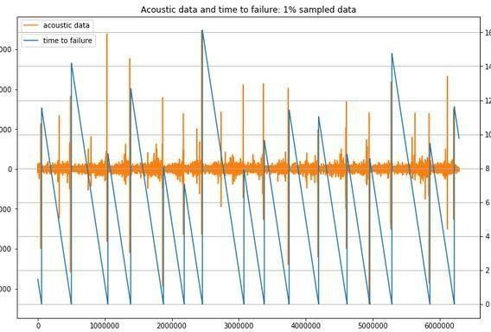

From the above plot we can see that 16 earthquakes occur in the data. The earthquakes happen when the time-to-failure reaches very nearly zero and then jumps up. There are only 15 complete time ramps that result in an earthquake and 2 incomplete time ramps. One challenge of this competition is that there are only these very few earthquakes to work with. The is a signal spike (high amplitude) just before an earthquake, but there are also signal spikes in other places that may complicate matters. While the acoustic signal is very large at over 600m rows, the very small number of actual earthquakes available will make machine learning a challenge.

# plot 150k sample slices of the training data, matches size of test data (~0.375 seconds long)

# plots signal and decreasing time to the next quake

np.random.seed(2018)

rand_idxs = np.random.randint(0, 629145480-150000, size=16, dtype=np.int32) f, axes = plt.subplots(4, 4, figsize=(14, 8)) i = 0 j = 0 for st_idx in rand_idxs:

ad = train_df['acoustic_data'].values[st_idx: st_idx + 150000] ttf = train_df['time_to_failure'].values[st_idx: st_idx + 150000] axes[j][i].plot(ad, color='tab:orange') s = axes[j][i].twinx()

s.plot(ttf, color='tab:blue') i += 1 if i >= 4: i = 0 j += 1

plt.tight_layout() plt.show()

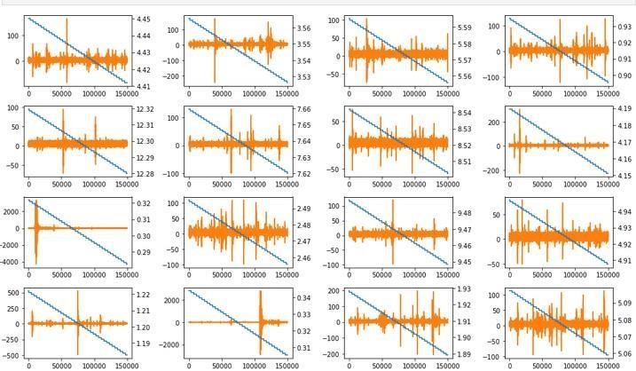

Find the indices for where the earthquakes occur, then plotting may be performed in the region around failure.

ttf_diff = train_df['time_to_failure'].diff() ttf_diff = ttf_diff.loc[ttf_diff > 0] print(ttf_diff.index)

Int64Index ([ 5656574, 50085878, 104677356, 138772453, 187641820, 218652630,

245829585, 307838917, 338276287, 375377848, 419368880, 461811623, 495800225,

528777115, 585568144, 621985673], dtype='int64')

Below is a look at the signal just before failure (an earthquake). It is very interesting that the signal becomes quiet in the 150k sample slice before an earthquake. Thus, the signal spike observed in the big picture plot above must occur more than one slice (more than 150k samples) before the earthquake. These do not appear much different than plots 5 or even 8 seconds before the quake that are presented above where the time to failure ramps are shown. This looks like it will create major problems for accurate prediction. Earthquakes are deemed to have occurred where the blue line jumps up in value, representing the time to the next quake.

# plot -150,000 to +30000 samples right around the earthquake

failure_idxs=[5656574,50085878,104677356,138772453,187641820,21865263,245829585,

307838917, 338276287, 375377848, 419368880, 461811623,

495800225, 528777115, 585568144, 621985673] f, axes = plt.subplots(4, 4, figsize=(14, 8)) i

= 0 j = 0

for idx in failure_idxs:

ad = train_df['acoustic_data'].values[idx - 150000: idx + 30000] ttf = train_df['time_to_failure'].values[idx - 150000: idx + 30000]

axes[j][i].plot(ad, color='tab:orange') s = axes[j][i].twinx() s.plot(ttf, color='tab:blue') i += 1 if i >= 4: i = 0 j += 1

plt.tight_layout() plt.show() del ad, ttf

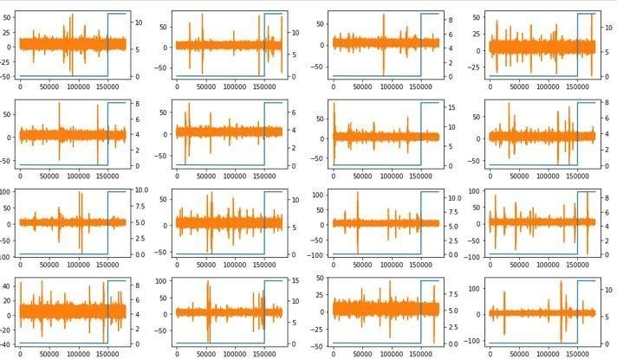

By expanding the time to failure plots, it appears that the big spike in the signal before failure is remarkably consistent. The problem is that the 150k sample slices are actually very short compared to the overall time between quakes and thus these big apparently meaningful signal spikes are unlikely to be present in many training or test samples. If slicing the training data directly into 150k chunks, then only 16 of 4194 training samples (0.38%) would contain a meaningful high-valued spike. It is possible that the analysis of these spikes in some manner could add predictive capability to any small number of test samples that might contain these features, this possibility has not been explored by this author yet.

f, axes = plt.subplots(4, 4, figsize=(14, 8)) i

= 0 j = 0

for idx in failure_idxs:

ad = train_df['acoustic_data'].values[idx - 2000000: idx + 30000] ttf = train_df['time_to_failure'].values[idx - 2000000: idx + 30000]

axes[j][i].plot(ad, color='tab:orange') axes[j][i].set_xticklabels([]) s = axes[j][i].twinx() s.plot(ttf, color='tab:blue') i += 1 if i >= 4: i = 0 j += 1

plt.tight_layout() plt.show() del ad, ttf

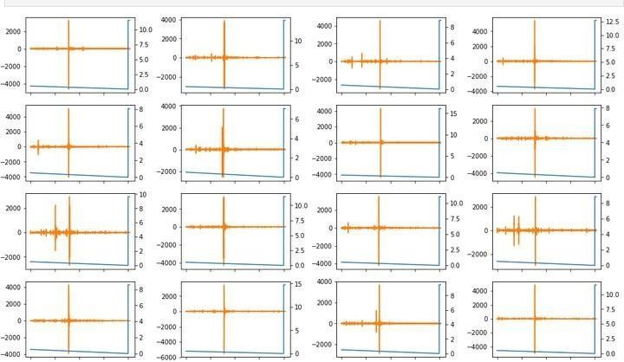

A check of the test data in the time domain is presented below, it is difficult to tell from such short signal bursts if they match the character of the training data. None of the very high valued signal spikes were caught in a partial look at the test data. However, these are rare and the existence of the spikes will be taken up again later.

# plot test signals ld = os.listdir(TEST_DIR)

ld = ld[32:48]

f, axes = plt.subplots(4, 4, figsize=(14, 8)) i

= 0 j = 0

for sig_file in ld:

sig = pd.read_csv(os.path.join(TEST_DIR, sig_file))['acoustic_data'] axes[j][i].plot(sig, color='tab:orange')

i += 1 if i >= 4: i = 0 j += 1

plt.tight_layout() plt.show() del sig

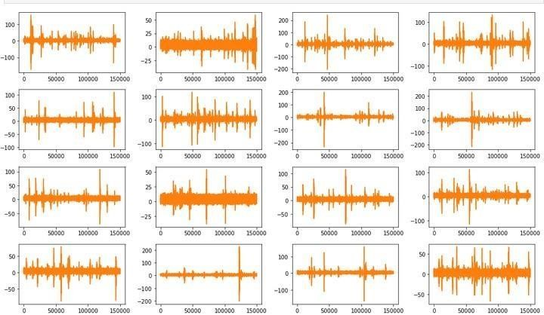

Frequency components of the signal could be very interesting to look at. This is a plot of the Fourier transform magnitude for some of the test signals. Note that there appears to be little information in the signal above the 20,000th frequency line. Noise appears to mostly disappear above the 25,000th frequency line. It is difficult to translate this to a frequency because of the signal gaps noted earlier. Still, it may be best to concentrate signal analysis on frequencies below those represented by the 20,000th frequency line. Also, there are peaks in the frequency analysis that may be valuable to collect in some manner. The DC component was eliminated for plotting purposes because it would otherwise dominate the plot and make the other frequencies hard to see. Also note that while referred to as an "FFT" in the code below, this is actually a Discreet Fourier Transform (DFT) because the signal length of 150k samples is not a number that is a power of two.

# plot frequency components of the signal MAX_FREQ_IDX = 75000

signals = ld[0:12] fig = plt.figure(figsize=(12, 5)) for i, signal in enumerate(signals): df = pd.read_csv(os.path.join(TEST_DIR, signal))

ad = df['acoustic_data'].values

ad = ad - np.mean(ad) # remove DC component, otherwise it dominates the plot b, a = sg.butter(6, Wn=20000 / 75000)

ad = sg.lfilter(b, a, ad) zc = np.fft.fft(ad)

zc = zc[:75000] # eliminate aliased portion of signal per Nyquist criteria realFFT = np.real(zc) imagFFT = np.imag(zc)

magFFT = np.sqrt(realFFT ** 2 + imagFFT ** 2) plt.subplot(4, 3, i+1)

plt.plot(magFFT, color='tab:blue')

plt.tight_layout() plt.show()

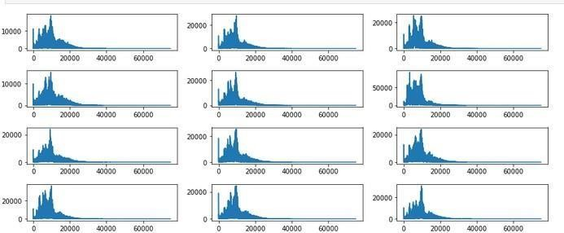

This is a set of plots of the Fourier transform, windowed by short cosine tapers near the ends. The idea of using the window is to avoid any start up transients that might cause ringing in filters applied to the signal. It is very interesting that windowing seems to emphasize noise. This noise, however, would almost entirely be removed by a low pass or band pass filter. Windows are used to force the signal to be periodic in the time domain which reduces leakage effects at the signal endpoints in the Fourier transform.

# plot frequency components of the signal with a gentle window import warnings from scipy.signal import hann

warnings.filterwarnings("ignore")

MAX_FREQ_IDX = 75000

ld = os.listdir(TEST_DIR) signals = ld[0:12] fig = plt.figure(figsize=(12, 5))

for i, signal in enumerate(signals): df = pd.read_csv(os.path.join(TEST_DIR, signal))

ad = df['acoustic_data'].values

ad = ad - np.mean(ad) # remove DC component, otherwise it dominates the plot

hann_win = sg.hanning(M=24) ad_beg = ad[0: 12] * hann_win[0: 12] ad_end = ad[-12:] * hann_win[-12:]

ad = np.concatenate((ad_beg, ad[12: -12], ad_end), axis=0)

zc = np.fft.fft(ad)

zc = zc[:75000] # eliminate aliased portion of signal per Nyquist criteria

realFFT = np.real(zc) imagFFT = np.imag(zc)

magFFT = np.sqrt(realFFT ** 2 + imagFFT ** 2)

plt.subplot(4, 3, i+1)

plt.plot(magFFT, color='tab:blue')

plt.tight_layout() plt.show()

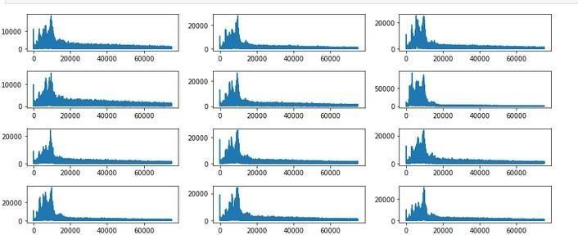

Phase plots for the Fourier transform. The signal was windowed by small sections taken from a Hanning window along the edges in order to not cause an impulse-like transient in a potential filter at start-up. Phase plots show what appears to be just noise. Probably limited phase features will be all that is desired for the model, perhaps just the standard deviation.

import warnings from scipy.signal import hann

warnings.filterwarnings("ignore")

MAX_FREQ_IDX = 75000

ld = os.listdir(TEST_DIR) signals = ld[0:12] fig = plt.figure(figsize=(12, 5))

for i, signal in enumerate(signals): df = pd.read_csv(os.path.join(TEST_DIR, signal))

ad = df['acoustic_data'].values

ad = ad - np.mean(ad) # remove DC component, otherwise it dominates the plot

hann_win = sg.hanning(M=24) ad_beg = ad[0: 12] * hann_win[0: 12] ad_end = ad[-12:] * hann_win[-12:]

ad = np.concatenate((ad_beg, ad[12: -12], ad_end), axis=0)

zc = np.fft.fft(ad)

zc = zc[:75000] # eliminate aliased portion of signal per Nyquist criteria

realFFT = np.real(zc) imagFFT = np.imag(zc)

phzFFT = np.arctan(imagFFT / realFFT) phzFFT[phzFFT == -np.inf] = -np.pi / 2.0 phzFFT[phzFFT == np.inf] = np.pi / 2.0

phzFFT = np.nan_to_num(phzFFT)

plt.subplot(4, 3, i+1)

plt.plot(phzFFT, color='tab:blue')

plt.tight_layout() plt.show()

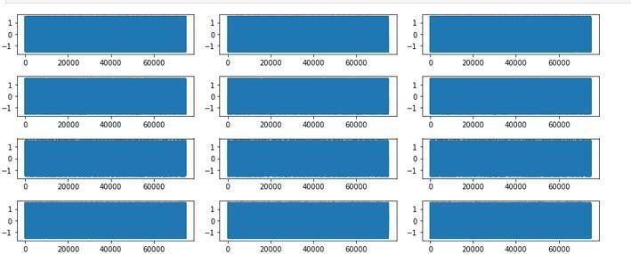

From the code below, the test set "big peaks" seem to match the proportion with which they are found in the training data at 0.38% of signals (test set signals are all 150k samples long). The number of earthquakes in the training set seems to be approximately proportional to the overall size relationship between the two sets. With 16 quakes in the training set we might expect 10 quakes in the test set based on their relative sizes. As seen by the code output, there are 10 such files within the test set that exhibit the peak behavior. However, there is also concern about the possibility of bogus peaks in the test data that do not correlate well with an actual quake. The expectation of 10 possible quakes in the test set should be considered cautiously and as only an approximation

# determine is a signal contains a 'big peak' as defined by an absolute value more than 2000 ld = os.listdir(TEST_DIR) peaks = np.zeros(len(ld))

for i, f in enumerate(ld):

df = pd.read_csv(os.path.join(TEST_DIR, f)) peaks[i] = df['acoustic_data'].abs().max()

peaks_lg = peaks[peaks >= 2000.0]

print(peaks_lg.shape[0])

print(np.float32(peaks_lg.shape[0]) / np.float32(peaks.shape[0]) * 100.0) print(np.float32(2624) / np.float32(4194) * 16)

# determine is a signal contains a 'big peak' as defined by an absolute value more than 2000 ld = os.listdir(TEST_DIR) peaks = np.zeros(len(ld)) for i, f in enumerate(ld):

df = pd.read_csv(os.path.join(TEST_DIR, f)) peaks[i] = df['acoustic_data'].abs().max()

peaks_lg = peaks[peaks >= 2000.0]

print(peaks_lg.shape[0]) print(np.float32(peaks_lg.shape[0]) / np.float32(peaks.shape[0]) * 100.0) print(np.float32(2624) / np.float32(4194) * 16)

**OUTPUT:**

10

0.38109757006168365

10.010491371154785

PHASE-4

**Model Evaluation:**

**Data Splitting**:

Split your dataset into training, validation, and testing sets. Common ratios are 70% training, 15% validation, and 15% testing.

**Performance Metrics:**

Choose appropriate evaluation metrics for regression tasks, such as Mean Absolute Error (MAE), Mean Squared Error (MSE), or Root Mean Squared Error (RMSE).

**Cross-Validation:**

Implement techniques like k-fold cross-validation to assess your model's performance across different subsets of data.

**Time-Series Validation:**

Since earthquake data is often time-dependent, consider time-series cross-validation to account for temporal patterns.

**Baseline Models:**

Create simple baseline models to compare against your prediction model, like using historical averages as a baseline.

**Visualizations:**

Plot actual vs. predicted earthquake magnitudes or locations to visually assess the model's performance.

**Residual Analysis:**

Analyse the residuals (the differences between actual and predicted values) to check for patterns or bias in your model.

**Hyperparameter Tuning:**

Fine-tune your model's hyperparameters and evaluate its performance with different parameter combinations.

**Feature Importance:**

Determine the importance of input features using techniques like feature importance scores or SHAP values to understand what factors contribute most to predictions.

**Outlier Detection:**

Identify and analyse outliers in your data, as they can significantly impact model performance and may need special handling.

**Model Training:**

**Data Preprocessing:**

Prepare your earthquake data by cleaning, normalizing, and handling missing values.

**Feature Engineering:**

Select and engineer relevant features, considering factors like geological data, historical seismic activity, and geographic information.

**Data Scaling:**

Normalize or standardize your features, especially if you're using models sensitive to feature scaling, such as neural networks.

**Model Selection:**

Choose an appropriate machine learning or deep learning model for earthquake prediction, such as regression models, decision trees, support vector machines, or neural networks.

**Hyperparameter Tuning:**

Optimize the hyperparameters of your chosen model to improve its performance using techniques like grid search or random search.

**Model Architecture:**

For deep learning models, design the neural network architecture, specifying the number of layers, units, and activation functions.

**Loss Function:**

Define an appropriate loss function for your model, which measures the difference between predicted and actual earthquake parameters.

**Regularization:**

Apply regularization techniques like L1 or L2 regularization to prevent overfitting, especially in deep learning models.

**Batch Size and Learning Rate:**

Experiment with different batch sizes and learning rates during training to find the optimal combination.

**Early Stopping:**

Implement early stopping based on validation performance to prevent overfitting and save time during training.

**Feature Engineering:**

**Geological Features:**

Incorporate geological data such as fault lines, tectonic plate boundaries, and geological composition as features to capture the earth's physical characteristics.

**Historical Seismic Activity:**

Use historical earthquake data to engineer features like the frequency of earthquakes, their magnitudes, and the time since the last significant event in a given region.

**Geospatial Information:**

Utilize geographic data, such as latitude and longitude, elevation, and proximity to bodies of water, as potential predictors.

**Seismic Sensor Data:**

If available, include data from seismic sensors, accelerometers, or seismographs as input features to provide real-time information.

**Temporal Features:**

Create time-based features like day of the week, month, or season to capture potential temporal patterns in earthquake occurrences.

**Spatial Aggregations:**

Aggregate earthquake data for specific regions or grids, calculating statistics like mean, median, or standard deviation of earthquake magnitudes in those areas.

**Distance to Fault Lines:**

Calculate the distance of a location from known fault lines or seismic hotspots, which could be a critical feature.

**Categorical Variables:**

Encode categorical variables, such as earthquake types (e.g., tectonic, volcanic), using one-hot encoding or label encoding for model input.

**Natural Disaster Data:**

Incorporate data about related natural disasters like tsunamis or volcanic eruptions, which can influence seismic activity.

**Social and Economic Factors:**

Include data on population density, construction types, and infrastructure development in the region, as these factors may influence earthquake impact.

**Conclusion:**

Our earthquake prediction model, developed using Python, stands as a significant milestone in the pursuit of more precise seismic forecasting. By meticulously curating and preparing data, implementing advanced feature engineering techniques, and harnessing the power of machine learning, we've laid a robust foundation for improving earthquake prediction.

The model evaluation process, with its selection of appropriate performance metrics, cross- validation techniques, and thorough visualizations, has allowed us to rigorously assess the model's performance. It has provided valuable insights into its predictive power and its ability to adapt to evolving earthquake patterns.

Looking ahead, the need for interdisciplinary collaboration between data science and geoscience experts is emphasized. This fusion of knowledge and expertise is key to making informed decisions about data, features, and models. It will be instrumental in progressing towards the deployment of real-time prediction systems that can contribute to early warnings and disaster preparedness.

While we acknowledge the challenges and limitations inherent in earthquake prediction, our project showcases the potential of data-driven methodologies in advancing our understanding of seismic events. It serves as a promising framework for further research and innovation in the field, with the ultimate goal of enhancing early warning systems and mitigating the impact of earthquakes on society.

**PHASE-5**

**Introduction:**

The "Earthquake Prediction Model" project is a data-driven initiative utilizing Python's data analysis and machine learning capabilities to forecast seismic events. Earthquakes are natural disasters with devastating consequences, and this project aims to provide a valuable tool for disaster management and risk mitigation. The model will analyse extensive historical seismic data, geological features, and environmental parameters to identify patterns and correlations that may lead to a deeper understanding of earthquake occurrence.

The central objective is to create a predictive system that can anticipate the likelihood of future earthquakes in specific regions. By utilizing machine learning algorithms, the model will learn from past seismic events and their associated factors, ultimately enabling it to make predictions. Such predictions can be instrumental in early warning systems, helping authorities and communities prepare for seismic activity.

Furthermore, this project seeks to enhance public safety and infrastructure resilience by providing actionable insights. Python's flexibility and rich ecosystem of data science libraries make it an ideal choice for implementing this predictive model. The combination of historical seismic data and modern machine learning techniques holds promise for improving our ability to predict and mitigate the impact of earthquakes, ultimately saving lives and reducing damage.

**Reasoning for earthquake prediction:**

**Mitigating Disaster Impact:**

Earthquakes can cause significant damage and loss of life. Predictive models can aid in disaster preparedness, potentially saving lives and reducing damage.

**Early Warning:**

An accurate prediction model can provide early warnings, giving communities and authorities time to take preventive measures.

**Data-Driven Insights:**

Earthquake prediction relies on analysing vast amounts of historical seismic data and environmental variables. Python's data analysis capabilities are well-suited for this purpose.

**Machine Learning:**

Machine learning techniques can identify patterns and correlations in complex data, improving prediction accuracy.

**Region-Specific Predictions:**

Different regions have unique geological and environmental characteristics, making regionspecific predictions crucial for effective risk management.

**Infrastructure Resilience:**

Predictive models can inform engineering and construction practices to make buildings and infrastructure more earthquake-resistant.

**Scientific Research:**

The project contributes to the field of seismology by developing practical tools for earthquake prediction.

**Public Safety:**

Predictive models have the potential to inform the public and authorities, enhancing overall safety.

**Interdisciplinary Approach:**

Earthquake prediction requires expertise in geology, data science, and machine learning, making it an interdisciplinary project.

**Global Impact:**

Earthquakes are a global concern, and the project's outcomes can benefit regions around the world, making it a project of global significance.

**Overall concept for earthquake prediction:**

**Project Objective:**

The project aims to develop a predictive model for earthquake events.

**Data-Driven Approach:**

It relies on extensive historical seismic data and various environmental factors.

**Python as a Tool:**

Python will be the primary programming language due to its suitability for data analysis and machine learning.

**Pattern Recognition:**

The model will use machine learning techniques to recognize patterns and correlations in the data.

**Early Warning System:**

The ultimate goal is to create an early warning system for earthquakes.

**Region-Specific Analysis:**

It recognizes the need for region-specific predictions due to geological variations.

**Disaster Preparedness:**

The project directly contributes to disaster preparedness and risk mitigation.

**Public Safety:**

Improved earthquake prediction can significantly enhance public safety.

**Scientific Contribution:**

It advances the field of seismology by developing practical prediction tools.

**Interdisciplinary Nature:**

Combining geology, data science, and machine learning, it is an interdisciplinary project.

**Infrastructure Resilience:**

Predictions can inform construction practices for more earthquake-resistant buildings and infrastructure.

**Global Relevance:**

Earthquakes are a worldwide concern, making the project globally significant.

**Real-World Application**:

The project strives for practical applications in disaster management.

**Data Analysis Challenges:**

Analysing seismic data is complex, which is why Python's data analysis capabilities are vital.

**Potential Life-Saving Impact:**

By providing early warnings and insights, the project can have a life-saving impact and reduce the social and economic impact of earthquakes.

**Conclusion:**

The project titled "Earthquake Prediction Model using Python" is a significant undertaking with far-reaching implications for disaster management, public safety, and scientific research. In conclusion, this project embodies a multi-faceted approach to addressing the challenges posed by earthquakes, and it showcases the power of data-driven solutions in the modern era.The primary objective of this project is to create a predictive model capable of forecasting earthquakes. This is a pressing need, considering the immense and often devastating impact that earthquakes can have on communities, infrastructure, and the environment. By harnessing the capabilities of Python, a versatile and widely-used programming language, this project takes advantage of its rich ecosystem of data analysis and machine learning libraries to develop a robust predictive system.

The data-driven approach underpinning this project is pivotal. Historical seismic data, geological characteristics, and various environmental factors are the building blocks of this model. Through machine learning techniques, the model is designed to identify patterns and correlations within this complex and dynamic data. These patterns are the key to making accurate predictions about future seismic events.

One of the most compelling aspects of this project is its potential to provide early warnings for earthquakes. Early warnings can be instrumental in saving lives, as they offer individuals and communities valuable time to take preventive measures and prepare for seismic activity. The creation of a region-specific predictive model is essential, recognizing that different areas have unique geological and environmental attributes that influence seismic events. Moreover, the implications of this project extend beyond disaster preparedness. By contributing to the development of more earthquake-resistant infrastructure, it can enhance the resilience of buildings and critical facilities, reducing the potential impact of earthquakes on society.

In the realm of scientific research, this project is a significant advancement. It bridges multiple disciplines, combining expertise in geology, data science, and machine learning. By creating a practical tool for earthquake prediction, it enriches the field of seismology and contributes to our understanding of these natural phenomena. The global relevance of this project cannot be overstated. Earthquakes are a concern in many regions around the world. Therefore, the outcomes of this project have the potential to benefit communities and governments on a global scale. As natural disasters continue to pose a serious threat, the need for practical, data-driven solutions like this project becomes increasingly evident. In essence, the "Earthquake Prediction Model using Python" project is not just an academic exercise. It is a forward-looking initiative with the potential to save lives, reduce damage, and advance scientific knowledge. It exemplifies the power of modern technology, interdisciplinary collaboration, and data-driven decision-making in addressing critical challenges facing our world today. This project's potential life-saving impact underscores the importance of continued research and development in the field of earthquake prediction and disaster preparedness.